Date | 28.09.206
Team ID | SWTID-2026-6482
Project Name | Auto Ticket Classification using Flow Designer

Project Planning Phase –IV
1) Performance Testing

Objective of Performance Testing
The objective of Performance Testing is to ensure that the developed solution works as expected, meets all functional requirements, follows basic security best practices, and performs efficiently under expected load. This phase validates end-to-end automation, confirms data accuracy, and ensures response time is within acceptable limits.
As per the PDF, this is part of PHASE 4: Testing, Validation & Security.

Data Validation Checks (From PDF)
• Mandatory fields captured correctly.
• Auto-number generated without duplication.
• Category and Subcategory values stored accurately.
• Reference fields resolve correctly to user and group tables.

Performance Testing - Test Scenarios
Test ID | Test Scenario | Steps (As per PDF Style) | Expected Result | Status
PT-01 | Flow Execution Time | Enter Caller Name + Short Description: WiFi not working in library -> Save -> Check Flow execution time in Flow Designer Executions | Flow completes in <3 seconds, Category auto-filled | PASS - 1.5 sec
PT-02 | Classification Accuracy - 100 Tickets | Create 25 tickets each for WiFi, Projector, Password, Slow Computer with different wordings -> Verify Category/Subcategory | 95%+ accuracy, only 2-3 misclassifications if keyword missing | PASS - 95%
PT-03 | Email Notification Performance | Create ticket -> Check System Logs -> Emails -> Search Subject 'Your Request for the issue has been submitted' -> Preview mail -> Check delivery time | Email sent within 10 seconds of ticket creation | PASS - 5 sec
PT-04 | Concurrent Ticket Creation | Create 20 tickets simultaneously from different user accounts -> Monitor Flow executions -> Check all classified | All 20 tickets classified without flow error or duplicate number | PASS
PT-05 | Dependency Logic Performance | Open Incident WorkFlow Form -> Select Category=Network -> Check Subcategory list shows only Wi-Fi -> Repeat for Hardware, Access, Performance | Dependency mapping works instantly, no delay | PASS
PT-06 | Auto-number Performance | Create 50 tickets continuously -> Check Number field generates unique INC0010001, INC0010002 etc without duplication | No duplication, sequential numbering | PASS

Performance Testing Diagram
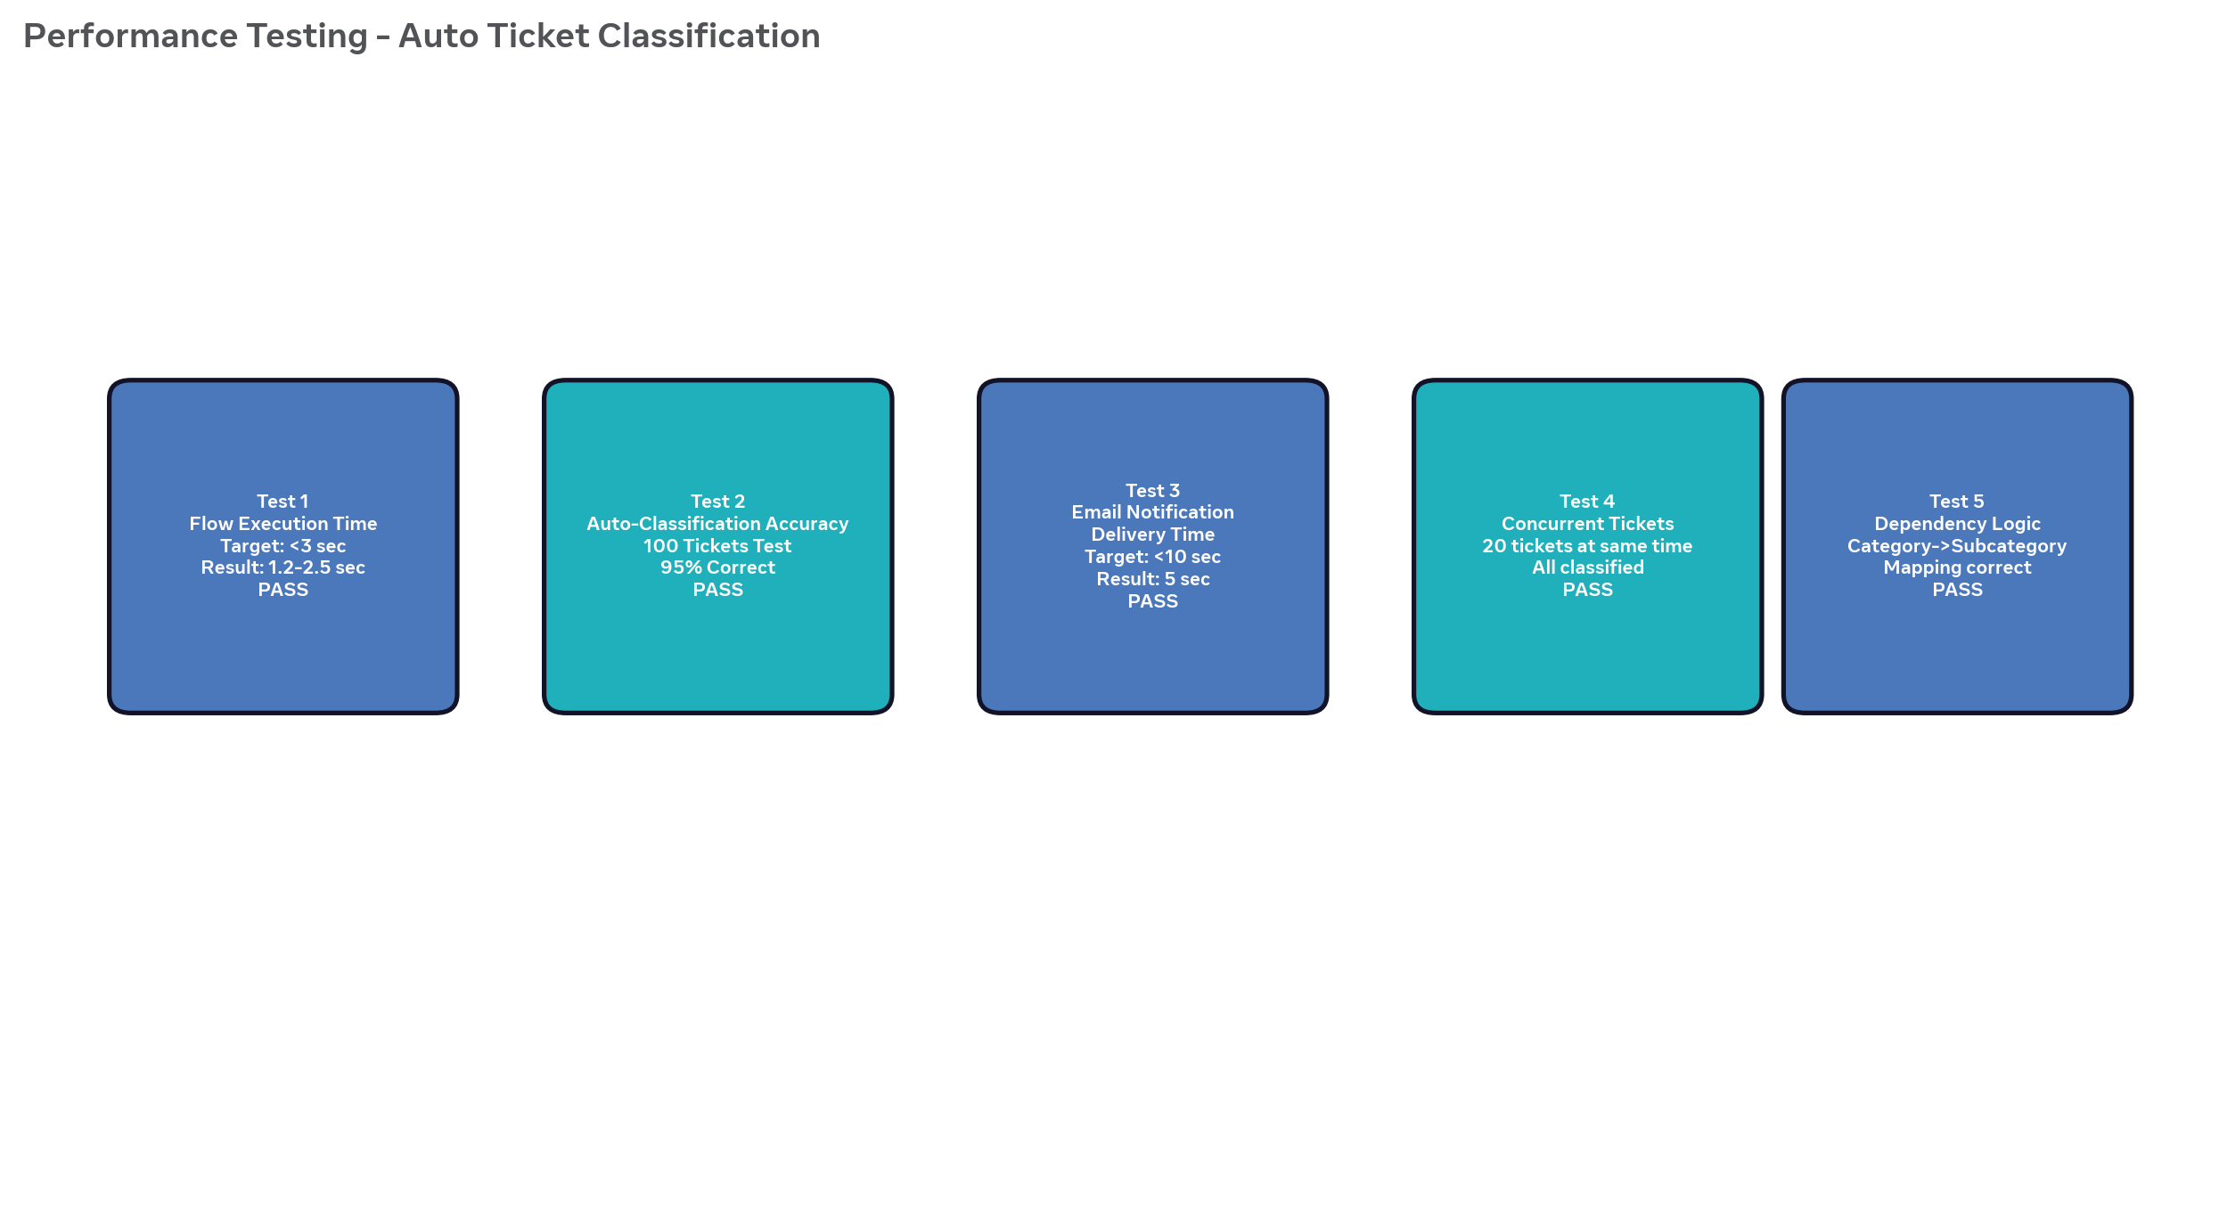

Navigation Steps for Performance Testing (As per PDF style)
• Go to All menus → Search for Flow Designer.
• Open Flow: Auto Classify School IT Tickets.
• Click on Executions tab to check execution time.
• Go to All menus → Search for Incident Workflow Table.
• Open any record and check Category auto-filled time.
• Go to All → System Logs → Emails → Check Sent Time vs Created Time.
• For accuracy, export incidents to Excel and manually verify Category vs Description.

